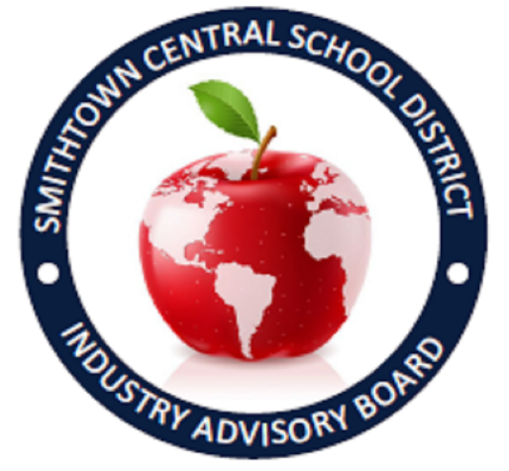
You are invited to celebrate
The 45th Anniversary of the Smithtown IAB
April 13, 2022 at 6 PM
WindWatch Golf and Country Club
This event is being combined with our
25th annual Business Etiquette Dinner
$65.00 PER PERSON
The following sponsorship opportunities are available:
- BRONZE - $100 to sponsor an individual student + 1 ticket for member
- SILVER - $250 per HALF table (Entitles Member to 1 & Sponsorship for 4 of our SHS students)
- GOLD - $500 per FULL table (Entitles Member to 2 tickets & Sponsorship for 7 of our SHS students)
- PLATINUM - $1000 (Please call to discuss this level)
- $50 to sponsor an Individual Student / $65 per Adult Mentor

Please RSVP here
OR
Call or e—mail Mary Pat Grafstein
631-382-5210 / mgrafstein@smithtown.k12.ny.us

Please make checks payable to:
Smithtown HS West – in Memo – Business Etiquette Dinner
Mail to: Mary Pat Grafstein / 10 School Street / St. James, NY 11780
(***Checks must be received by April 12, 2022***)
As always, we thank you for the support and guidance that you provide
for the students of Smithtown Schools.

